 

INSTITUTE FOR ADVANCED COMPUTING AND SOFTWARE DEVELOPMENT AKURDI, PUNE

Documentation On

**“Blood Bank Management System”**

E-DAC MAY 2021

*Submitted By:*

**Group No: 32**

**Chetan Vadingekar 1038**

**Vaibhav Mule 1121**

**Mr.Prashant Karhale Mr.Kashinath Patil**

**Centre Coordinator Project Guide**

**Table of Contents**

1. Introduction 1
   1. Document Purpose 1
   2. Problem Statement 2
   3. Product Scope 2
   4. Aim and Objectives 2
2. Overall Description 3
   1. Functional and Non-Functional requirement 3
   2. Operating Environment 4
   3. Design and Implementation Constraint 5
3. Requirements Specification 6
   1. External Interface Requirements 6
4. System Diagram 7
   1. Activity Diagram 7
   2. Data Flow Diagram 8-10
   3. Use Case Diagram 11-13
   4. ER Diagram 14
5. Table Structure 15
   1. Users 15
   2. Donors 15
   3. Organization 15
   4. Donors_Info 16
   5. Buyers_Info 16
6. Snapshot 17

6.1 Home Page 17

6.2 Login page 17-19

6.3 Admin Page 20

6.4 Blood Stock 20-21

1. Conclusion 22
2. References 23

# Introduction

The main aim of developing this system to provide blood to the people who are increasing in large number day by day. This blood bank management system is an online website, so it is easily available to everyone. When person want to donate blood, he/she must register to the system. Donor registration is very easy. Admin will manage the blood stock and organization details for blood donation campaigns. When person want to buy the blood bag, he/she can register to the system to check availability of blood stock to buy a blood bag.

### Document Purpose

The focus of this system is to provide an online easy access to blood stock and manage blood stock data available, so that using this blood bank management system people can search blood group available they need. It will replace the paperwork. It keeps records of donor, buyer, and blood stock.

This system helps the customer to enquire the availability of blood they need. Second module helps him to make a payment and reserve a ticket.

* First module helps donors and buyers to access the system by simple

registration

* Second module will be accessed by Admin to manage the stock details

and organization details.

### Problem Statement

The proposed blood bank management system helps the people who need blood by giving them all the details of blood group availability. This saves the time as he can search the blood required without going anywhere. This website works 24*7 so user can get the information of blood required any time.

### Product Scope

* + Secure registration and blood stock availability for users.
  + User can buy blood online.
  + Browsing through the System to see the availability of blood group required. Donor can register online to donate the blood.
  + This web application will help the people in need of blood to save the life of their relative or friend.
  1. **Aims and Objectives**

Specific goals are: -

* + To produce a web-based system that allows the admin to manage the blood stock.
  + To ease donor/buyer the process of buying or donating the blood.

### Functional and Non-Functional requirements of Blood Bank Management System

**Functional Requirements:**

**1)Admin:**

-Manage the Registration of users, donors, and organization.

-View User/Donor and organization information.

**2)User:**

-Check the blood availability.

-Register

-login

-Post the blood request

**3)Donor:**

-Register

-login

-Book an appointment to donate blood.

**4)** **organization:**

**-**registration

**-**login

**-**Schedule the blood donation campaign.

**Non-Functional Requirements:**

**1)Availability-**

-Users & Donors can access this management system from anywhere

from this web application.

**2)Security:**

-Users and Donors information should be kept confidential under security system.

-The system automatically logs out after the period of inactivity.

**3)Reliability:**

-System will be reliable enough to provide intact information about to user and donor.

-Once the blood is donated or request for blood is post user or donor will

receive the notification on the same.

**4) Performance:**

-Basic system configuration is enough to access the web application.

-Users and Donors can access the web application from mobile phones with minimal

performance of the same.

-Performance of the system remains same regardless of platform either it is laptop or

mobile phone.

### Operating Environment:

* Server Side:

**Processor**: Intel Dual Core

**HDD**: Minimum 80GB Disk Space **RAM**: Minimum 4GB

**OS**: Windows 7 or above **Database**: MySQL8.0

* Client Side (minimum requirement):

**Processor:** Intel Dual Core

**HDD:** Minimum 80GB Disk Space

**RAM:** Minimum 4GB

**OS:** Windows 7 or above

### Design and Implementation Constraints:

* The application will use React and Bootstrap as main web technologies.
* HTTP and FTP protocols are used as communication protocols. FTP is used to upload the web application in live domain and the client can access it via HTTP protocol.
* Several types of validations make this web application a secured one and MySQL Injections can also be prevented.
* Since Blood Bank Management System is a web-based application, internet connection must be established.
* The Blood Bank Management System will be used on PCs and will function via internet or intranet in any web browser.

1. **Requirement Specification**

### 3.1 External Interface Requirements:

* User Interfaces:
  + All the users will see the same page when they enter in this website. This page asks the users a email and a password.
  + After being authenticated by correct email and password, user will be redirected to check the availability of the blood group they need and donors will be directed to fill the registration form.
  + The user interface will be simple and consistence, using terminology commonly understood by intended users of the system. The system will have simple interface, consistence with standard interface, to eliminate need for user training of infrequent users.
* Hardware Interfaces:
  + No extra hardware interfaces are needed.
  + The system will use the standard hardware and data communication resources.

1. **System Design**

### Activity Diagram

This is Activity UML diagram of Blood Bank Management System which shows the flows between the activity of stocks, user, donor and organize.

**Figure 1: Activity Diagram**

### 4.2 Data Flow Diagram

**1.Zero Level Data Flow Diagram [0 Level DFD] of Blood Bank Management System:**

This is the Zero Level DFD of Blood Bank Management System, where we have elaborated the high-level process of Blood Bank. It’s a basic overview of the whole Blood Bank Management System or process being analyzed or modelled. It’s designed to be an at-a-glance view of Admin, User, Donor, and organization showing the system as a single high-level process, with its relationship to eternal entities of blood group.it should be easily understood by a wide audience.

**Figure 4: Level 0 Data Flow Diagram**

**2.First Level Data Flow Diagram [1st Level DFD] of Blood Bank Management System:**

First Level DFD [1st Level DFD] of Blood Bank Management System shows how the system is divided into sub-systems(processes), each of which deals with one or more of the data flows to or from an eternal agent, and which together provide all of the functionality of the Blood Bank Management System as a whole.it also identifies internal data store of User, Donor, Blood Stocks and Organizations.

**Figure 5: Level 1 Data Flow Diagram**

**3.Second Level Data Flow Diagram [2nd Level DFD] of Blood Bank Management System:**

DFD Level 2 then goes one step deeper into parts of Level 1 of Blood Bank. It may require more functionalities of Blood Bank Management to reach the necessary level of details about the Blood Bank functioning. First level DFD of BBMS shows how the system is divided into sub-systems. The 2nd Level DFD contains more details of User, Donor and Organization.

**Figure 6: Level 2 Data Flow Diagram**

### 4.3 Use Case Diagram

This use case Diagram is a graphical depiction of the interactions among the elements of Blood Bank Management System. It represents the methodology used in the system analysis to identify, clarify and organize system requirements of Blood Bank Management System. The main actors of Blood Bank Management System in this Use Case Diagram are: Admin, User, Donor and organizations who perform the different types of use cases shown on the picture below.

**Figure 7: Use Case Diagram1**

**Figure 8: User Use Case Diagram2**

**Figure 9: Donor Use Case Diagram3**

## ER Diagram

This ER (Entity Relationship) Diagram represents the model of Blood Bank Management System Entity. The entity-relationship diagram of Blood Bank Management System sows all the visual instrument of database tables and the relations between Admin, User, Donor, Organization and Blood stocks etc. It used structure data and to define the relationship between structured data groups of Blood Bank Management System functionalities.

**Figure 10: ER Diagram**

14

# Table Structure

### 5.1 Users:

* 1. **Donors:**

* 1. **Organization:**

15

* 1. **Donors Info:**

* 1. **Buyer Info:**

16

# SnapShots

**

* 1. Login PageA screenshot of a computer

     Description automatically generated

17

18

19

* 1. Admin Page

* 1. Blood Stock Page

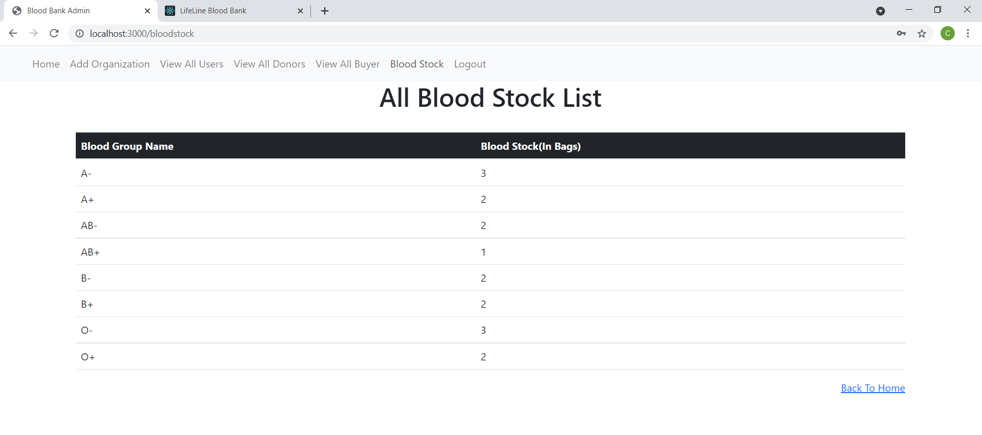

20

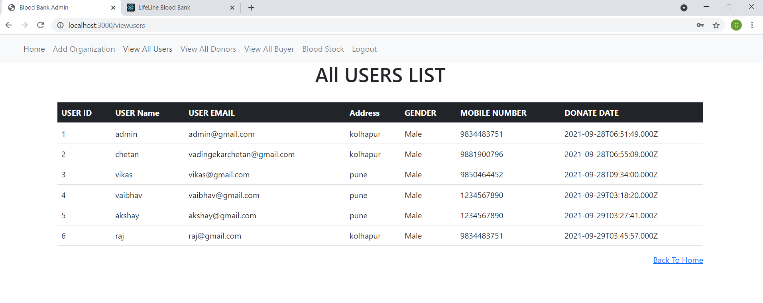

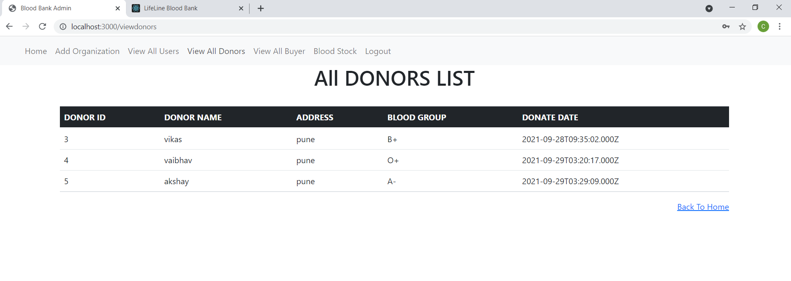

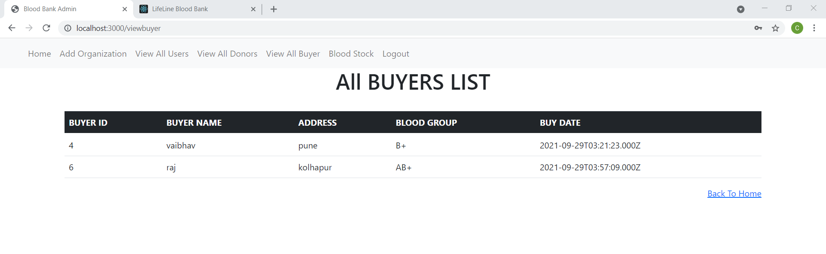

21

# Conclusion

Using this project “Blood Bank Management System” people can search blood group available which they need. They check the details using blood bank management website. The main benefit of this system is the information

of available blood group. This will save the time and eventually help to save the life

of a person who is in extreme need of the blood in an emergency. This website works 24*7 so user can get information of blood required at any time.

22

# References

1. <https://www.oxley.com/domain/text.com/>
2. <https://app.diagrams.net/>

23